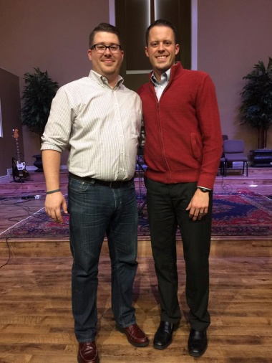

**March 27-29**

**March 27-29**

**9th Annual Bible Conference Power Lunch**

**Dr. Jeremy A. Rogers**

**Senior Pastor- Arlington Park Baptist Church, Arlington**

**Jordan N. Rogers**

**Senior Pastor- Hillcrest Baptist Church, Nederland**