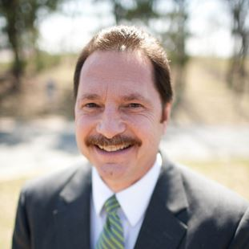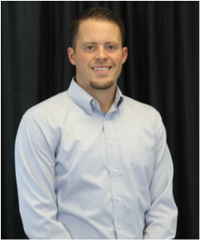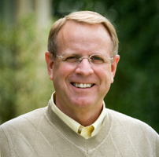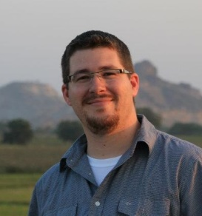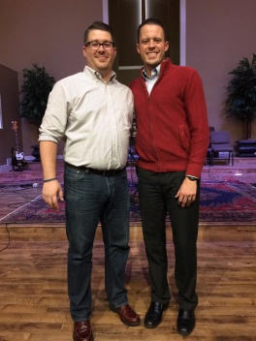

Dr. Ben Awbrey

Sunday March 26th

Jordan N. Rogers

Monday & Wednesday March 27th & 29th

Dr. Tom Elliff

**Tuesday March 28th**

Jeremy A. Rogers

**Sunday March 26th**

**SEE MORE AT**

[**www.southsidebowie.weebly.com/**](http://www.southsidebowie.weebly.com/)

Jeremy and Jordan Rogers

**Power Lunch Monday-Wednesday**