Messages:
3/23 (10:50 AM) “God’s Covenant Marriage” (Ephesians
5:31-33)
3/23 (6:25 PM) Concert by Glowing Heart
3/24 (6:55 PM) “We Will Tell” (Psalm 78)
3/25 (6:55 PM) “Children, Obey Your Parents” (Exodus 20:12)
3/26 (6:55 PM) “The Prodigal Son” (Luke 15:11-32)
3/24-26 (11:45AM) “The Model Church: A Sermon Series through 1 Thessalonians” (1 Thessalonians 1-5)

SPEAKERS
Dr. Jerry Johnson
Dr. David Allen
Jordan Rogers
Dr. Jim Richards
Dr. Nathan Lorick
Dr. Jeremy A. Rogers

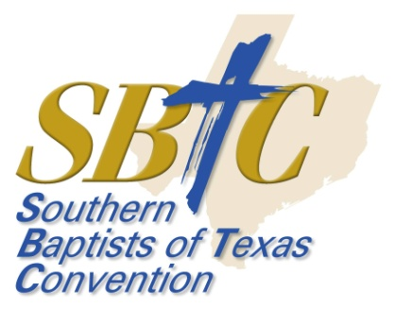

Southside Baptist Church
311 W. Wilbarger St.
Bowie, Texas 76230
940-872-2793
southsidebowie@sbcglobal.net
Pastor: Tony A. Rogers
www.southsidebowie.weebly.com/

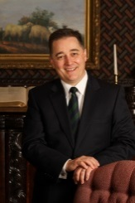
Dr. Jerry Johnson
President, The Criswell College (Dallas, TX). Preaching Sunday morning 10:50 AM (3/23/14).
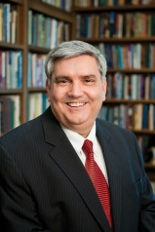
Dr. David Allen
Dean of Theology, Professor of Preaching- Southwestern Baptist Theological Seminary (Ft. Worth, TX). Preaching Sunday evening 6:25 PM (3/23/14).
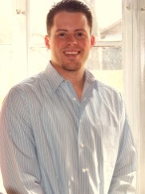
Jordan Rogers
Senior Pastor- Letitia Baptist Church (Lawton, OK), VP- Jeremiah 20:9 Ministries (Bowie, TX). Preaching Monday evening 6:55 PM (3/24/14).
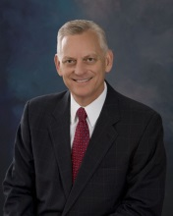
Dr. Jim Richards
Executive Director- Southern Baptist Texas Convention (Grapevine, TX). Preaching Tuesday evening 6:55 PM (3/25/14).
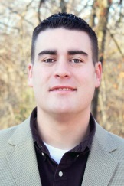
Dr. Nathan Lorick
Evangelism Director- Southern Baptist Texas Convention (Grapevine, TX). Preaching Wednesday evening 6:55 PM (3/26/14).
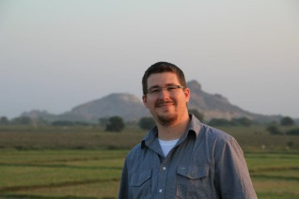
Dr. Jeremy A. Rogers
Senior Pastor- Arlington Park Baptist Church (Arlington, TX), VP- Jeremiah 20:9 Ministries (Bowie, TX). Serves as our Power Lunch Pastor; preaching Monday-Wednesday 11:45-1:00 (3/24-26/2014).

Plan now to attend, bring a friend & we will see you there!
Bro. Tony

We will also have great singing!
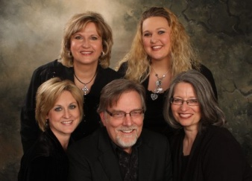  SPOKEN FOR  Richardson |  | GLOWING HEART  Grand Prairie
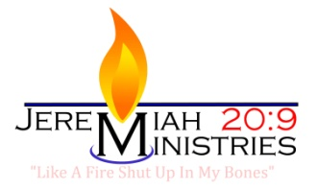  Bowie | 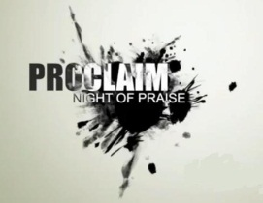  Proclaim  Lawton, OK | Amy Hill  Wichita Falls

TIMES
Sunday 10:50 AM
Sunday 6:25 PM
Monday 6:55 PM
Tuesday 6:55 PM
Wednesday 6:55 PM

POWER LUNCH
11:45-1:00 PM Monday-Wednesday
4$ Lunch
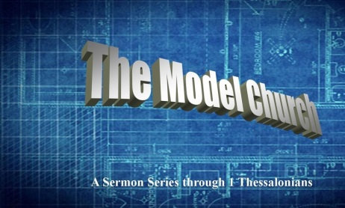
Come for a great time of Bible
Study. You do not have to eat to
come to the Bible Study. All are
welcome. Bring a friend as our
Power Lunch Pastor shares the
topic: The Model Church: A
Sermon Series through
1 Thessalonians

