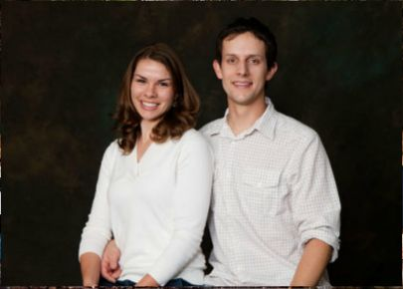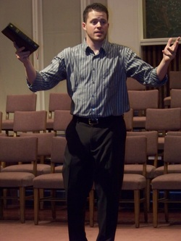Jason Morgan.JPG

Worship Led By:

**“God’s Compassionate Word for the World”**

**Wednesday March 28, 6:55 PM**

**@ Southside Baptist Church Bowie, TX** [**www.southsidebowie.weebly.com**](http://www.southsidebowie.weebly.com)

**2012 Bible Conference**

**Youth Night**